*PLEASE NOTE: WE WILL BE FOLLOWING AND WILL RESPOND TO CDC GUIDELINES
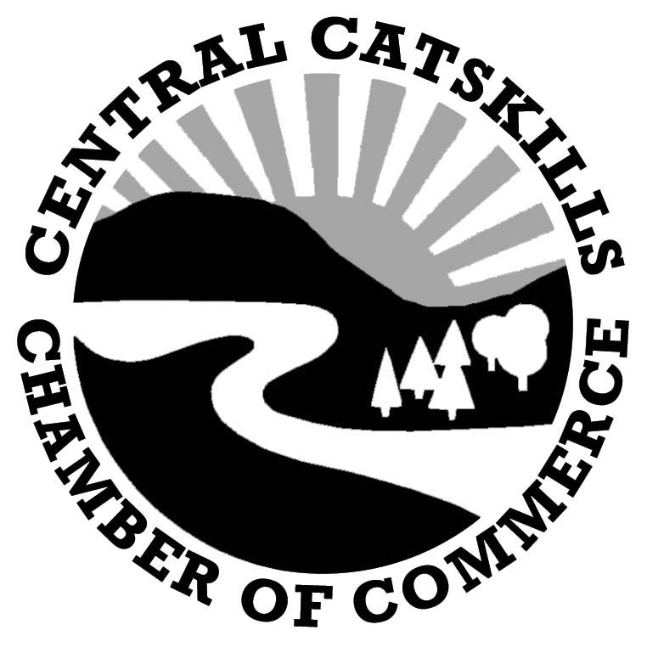
Margaretville Cauliflower Festival 2021
Sponsored by
The Central Catskills Chamber of Commerce

Community Not for Profit Vendor

Mark your calendar! The 17th Annual Cauliflower Festival sponsored by the Central Catskills Chamber of Commerce is scheduled for Saturday, September 25th, from 11am-4pm at the Margaretville Village Park (behind Freshtown on Bridge Street and Route 28). Rain or Shine!

This old-fashioned country fair is held at the peak of the colorful fall season. ONE NEW FEATURE WILL BE A CELEBRATION OF THE QUILTING HALL OF FAME organization plus demos and lots of quilts to enjoy seeing. An outdoor exhibit will be held next to BLOOM Quilts and Retreat on Main Street.
The 2021 Endurance Run an annual car rally will join us again this year too. Arrival is expected just after noon and will bring the excitement of amazingly restored and maintained antique cars. www.1903autorun.org for more information. Take pictures, talk to car owners and enjoy hearing their stories.

The cost for a 12’x12’ space is $50. COMMUNITY NOT FOR PROFIT VENDOR FESTIVAL FEE IS $30.
Each vendor is responsible for providing their own table(s), chairs and tent and must remove their own trash at the end of the day. There is no access to electricity. Set-up time starts at 8am.
Carol O’Beirne, Chamber – 845-586-3300 carol@centralcatskills.com

Community Not for Profit Vendor Application

Name: ________________________________Phone #: ____________________

Business: __________________________website: _________________________

Mailing Address:_____________________________________________________

e-mail address: __________________________________________________

Number of Spaces: ____________Check#:__________ Amount: ______________

Signature of Applicant: _________________________________________________________________

Rain or shine. Mail application to: CCCC, PO Box 605, Margaretville, NY 12455.

